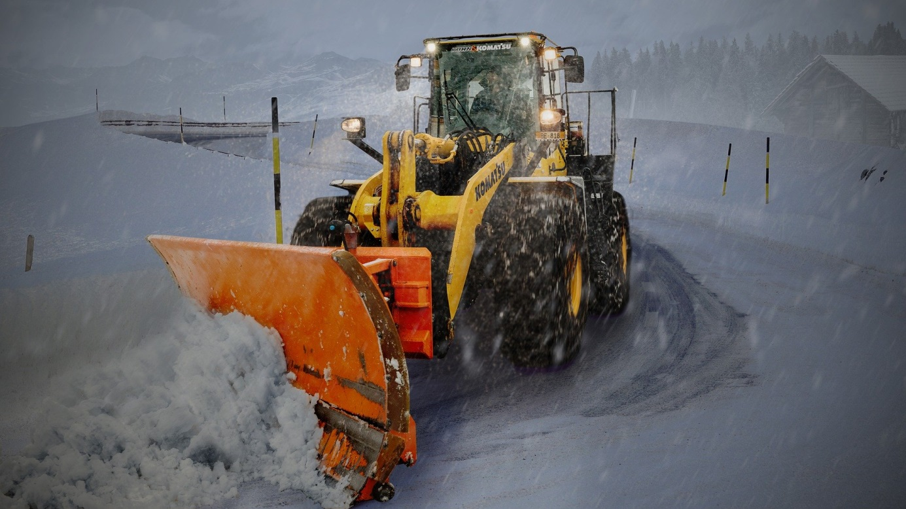
Winter work – Employers’ duties
For the OHS service, the winter seasons begins as early as 1 November and lasts until 31 March. Under OHS legislation, employers are under additional obligations in relation to ensuring adequate work conditions given lower outside temperatures.
The temperature on the work premises should be adequate to the type of works being performed, but it must never be lower than 14°C unless technological reasons prevent it from being higher. In workplaces where light physical work is done as well as in offices, temperatures must not be lower than 18°C.
In particularly uncomfortable conditions, including outdoor works during winter, free-of-charge meals and refreshments must be provided by the employer, with their temperatures and kinds matching the actual conditions of work.
Special rooms must be ensured to workers working outside in the open air for warming up or changing clothing. The temperature in such rooms should not be lower than 16°C. Where the air temperature falls below 10°C, the employer must also ensure protective clothing.
Special care and caution should be exercised during construction works. Snow, high wind and low temperatures represent additional hazards, particularly during work at heights or in the open air.

Small businesses are struggling with OHS compliance
One in six of what was the State Labour Inspectorate’s first audit resulted in a fine, court petition or prosecutor information. The violations involved primarily failure to comply with OHS regulations.
Similarly to the preceding years, in virtually every first-time audited business an average of 12 various irregularities were identified. The outcome is a gloomy picture of the problems with labour-law compliance.
The audit of occupational health and safety has shown numerous irregularities in respect of occupational risk assessment (lack of documentation) and substantive errors. These were identified in 39% of the firms audited.
Material irregularities were identified in respect of OHS training (40% of audited firms). It was established that 11% of the firms audited had failed to deliver induction training (general and workstation tutorials) in OHS, with 29% failing to conduct periodical training.
Creating and complying with OHS procedures and manuals has turned out to be another serious problem in the audited firms. As many as 40% of the businesses never developed the OHS manuals required.
32% of the audited entities failed to ensure an efficient first-aid emergency system or proper first-aid equipment.
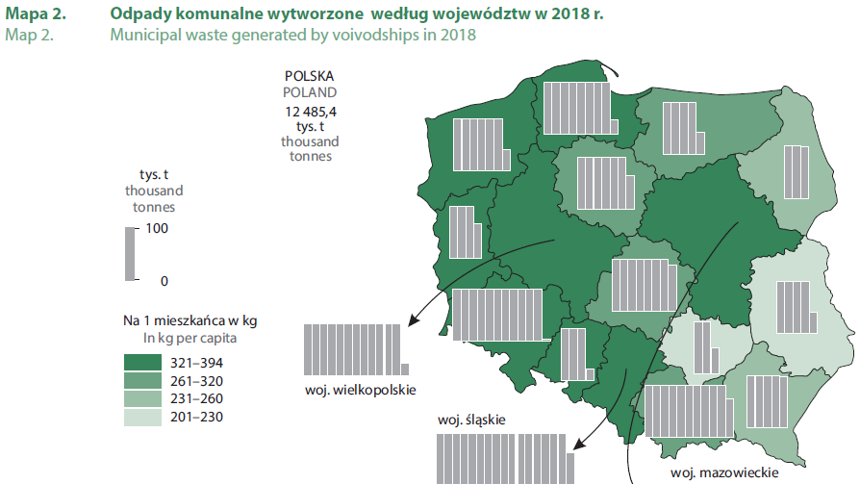
Poles generating more waste

The latest data from the Main Statistical Office show that Poles generated more waste in 2018 than a year before with 325 kg per citizen. Notably, household waste sorting has improved, rising by 11% compared to the preceding year.
12, 485 thousand tonnes of household waste was generated in 2018, which represented a 4.3% rise on the preceding year. This means an increase in the household waste generated per capita from 311 kg in 2017 to 325 kg in 2018.
The most waste is being generated by the inhabitants of the Lower Silesia Voivodship. The lowest rate was that of the Świętokrzyskie region. Rural communities generate less waste. Less than 200 kg of waste per capita was collected from 38% municipalities (primarily rural communities). The greatest amounts of household waste are generated in touristic communities – more than 1,000 kg of household waste was collected in six of such communities.
The amounts of wasted collected through sorting has been rising year by year. In 2018, over 3.6 million tonnes of waste was collected sorted (29% of all household waste generated), which represents an increase of 11% compared to the previous year. 106 kg of waste per capita was collected sorted in cities in 2018, with a mere 76 kg in rural areas.
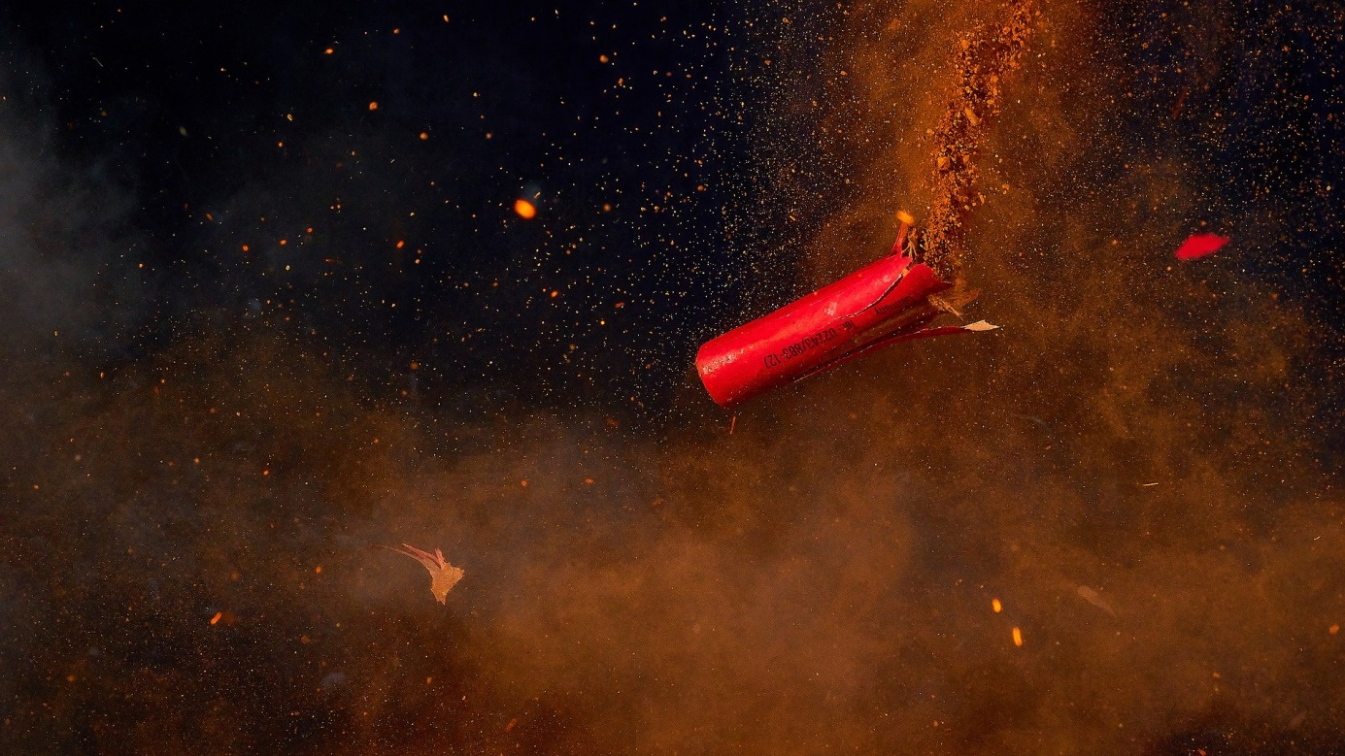
Fireworks – Safety Rules
Fireworks, flares, bangers or firecrackers are indispensible to New Year celebrations. They are pyrotechnic products, and their sales, storage and use are legally regulated. Improper handling of these products could entail health and legal implications.
Currently, the law in Poland only allows the public use of pyrotechnic products on a single night – i.e. that between 31 December and 1 January. It is forbidden on other days unless permission is granted by the relevant mayor.
According to police statistics, there are several hundred burns, injuries, fires and even fatal accidents on that night every year. The single most frequent cause of such incidents is improper handling of these products as well as failure to comply with safety rules.
Remember: a petard you are holding that is about to explode can result in burns to your hands and face, as well as other more serious injuries, including loss of sight, fingers or even an entire hand.
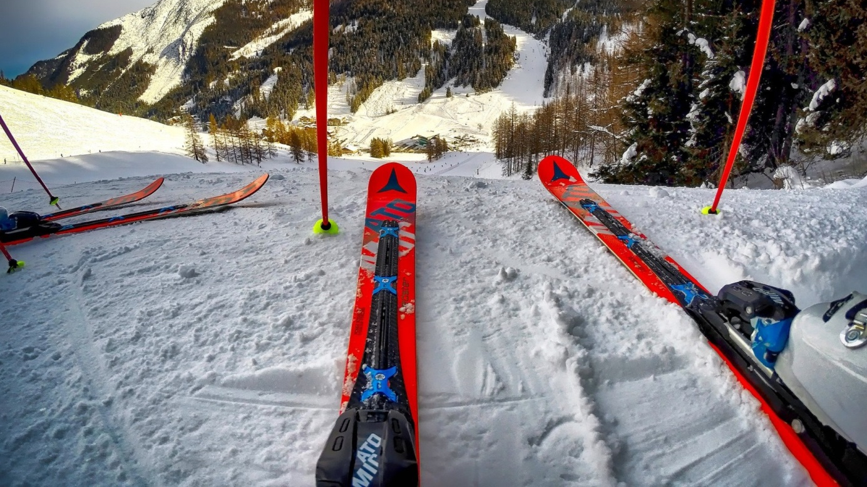
Safety on the slope
Following safety rules helps prevent serious accidents both at work and outside the workplace. Back in 2002, the International Skiing Federation (FIS) published a Code of Rules which should be considered an ideal model of conduct for a responsible and cautious winter sport fan.
- Respect others. Behave so as not to expose others to danger.
- Control your speed. Adjust your speed and skiing style to your personal skills and the conditions around you.
- Choice of route. Select your route so as to avoid exposing others to danger.
- Overtaking. You can overtake as long as the person ahead has enough room to perform all intended or unintended manoeuvres.
- Starting up and going uphill. Remember to do so without causing threat to yourself or others.
- Stopping on the slope. Avoid stopping on the route/piste unless absolutely necessary.
- Going up or downhill on foot. Keep to the side of the slope while going up or descending.
- Follow the signs. Always follow strictly all signs and route or piste markings.
- Help if there is an accident. In the event of an accident, everyone is under an obligation to rescue the injured.
- Identity disclosure. Whether you are have witnessed, caused or suffered an accident, you are required to disclose your personal data.
Fire safety as part of OHS training
The rules of fire safety should be known to every member of staff of a company or institution for which he or she provides work. Fire safety regulations are typically presented during obligatory OHS training.
Under the law, it is the employer’s obligation to communicate to its staff fire safety regulations and rules of conduct in the event of fire or emergency of another type. Fire safety issues are covered, as a rule, during OHS training as specified in a regulation of the Minister of Economy and Labour on training in occupational health and safety.
During the general OHS instruction, an employee should learn about:
- Potential sources of fire threats,
- Rules of conduct in the case of fire,
- Evacuation rules,
- Use of handheld fire-fighting equipment, particularly taking into account the specific conditions in the workplace in question.
During workstation tutorials, fire safety matters are dealt with if fire hazardous materials are used in the company’s production processes.
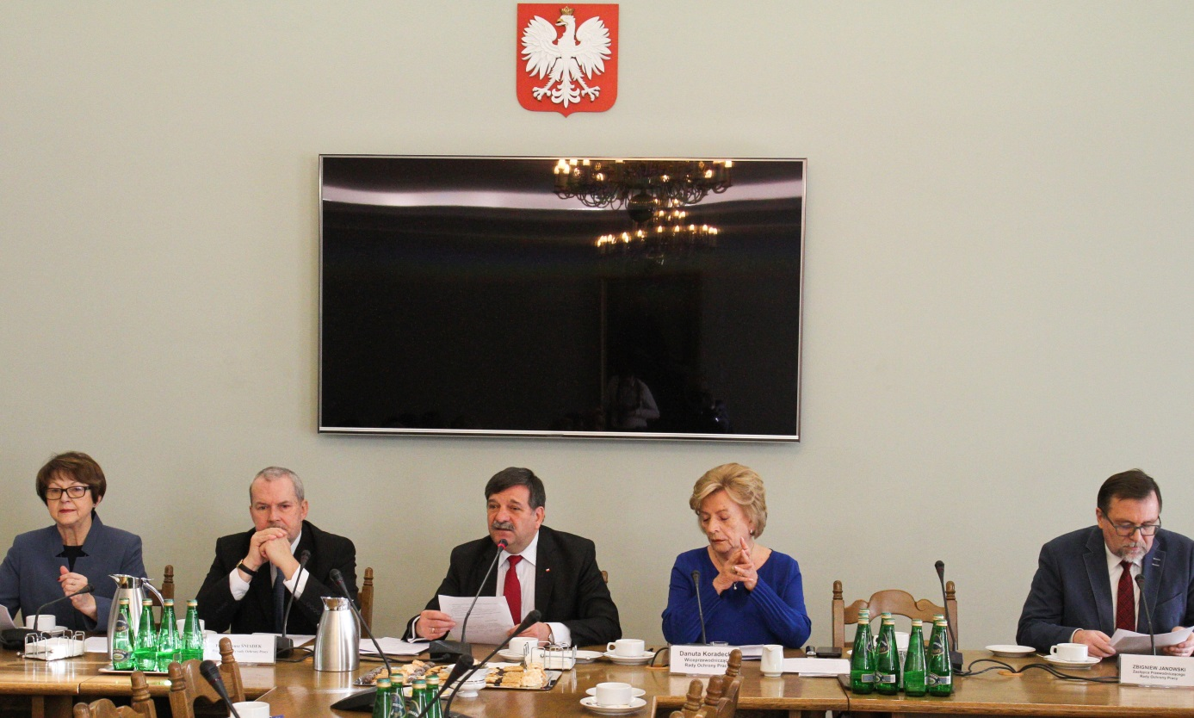
The PIP to conduct 72,000 audits in 2020
On 18 December 2019, Chief Labour Inspector Wiesław Łyszczek presented in the Sejm a schedule of works of the State Labour Inspectorate for the year 2020. As well as long-term campaigns, audits will be carried out in areas where the greatest numbers of hazards occur. Construction is one such industry.

Where will audits be carried out?
- At companies and institutions where accidents at work have occurred.
- In workplaces involving exposure to carcinogenic or mutagenic factors.
- At employers’ that have completed actions adjusting their companies to legal standards.
- In the construction industry, the audits will also include an assessment of OHS-legislation compliance at works involving tower and fast-erecting cranes.
- At healthcare providers. The audits aim to mitigate the impact of hazards involved in the preparation, administration and storage of cytotoxic medicines.
- At medical care providers, the audits will cover both hospitals and outpatient units.
- In the mining industry – the audits will focus on identification of irregularities that could result in threats to the lives or health of the staff.
- In trade, the audits will include verification of compliance with the act on limited trade on Sundays and public holidays as well as certain other days in force since 2018.
Virtual Reality in OHS
In the OHS industry, efficient teaching methods are of crucial importance as the knowledge acquired could be critical at one point to saving someone’s life or health. Hence, a trainee should be exposed to such visual forms that will minimise the risk of distraction or fatigue. One such method entails the use of VR technologies.
Virtual Reality ensures information remembering at an average level of 75%. By contrast, reading content is normally absorbed at a rate of 10% while traditional lecturing does not normally exceed 50%. Thus, VR is a tool that is a strong competitor to the traditional teaching methods, and its use in the OHS sector brings about considerable benefits that easily translate themselves into human safety, health and life.
VR will also prove useful in fire safety training, induction training, evacuation drills, learning fire safety manuals, training for visitors, firms, offices or hotels.
Not only do VR applications provide an experience of the threat, but they can also be used to measure the training efficiency and assess the users’ knowledge. Each trainee is given scores, marks and information, which allow a creation of a score table for particular tasks. A specialist trainer can easily assess the trainee’s knowledge, create reports and monitor the group’s progress.
A draft BDO (Waste Database) regulation could save small businesses
On 14 December 2019, Michał Kurtyka, the Minister of Climate, sent for public consultation a draft regulation on the types and amounts of waste that is not subject to public records. The regulation in question will affect primarily small and medium-sized businesses.
The statement of reasons for the draft provides that annual waste generation is minimal in the service and retail trade industries where business is often done by sole traders. Waste generation entails an obligation to keep its qualitative and quantitative records with an annual report to be filed with the Voivodship Marshal (regional administrative authority).
Thus, released from the waste record-keeping duties will be businesses generating waste other than household waste, except for dangerous waste, in the course of their business, such as: packaging waste – the amount of waste for which records need not be kept is between 0.2 and 1 tonne; computer disc or CD waste (up to 50 kg); groceries that have expired or are unfit for consumption (up to 0.1 tonne); construction waste: wall plaster, wallpaper and lining – between 5 and 10 tonnes depending on the type.
It is estimated that approx. 1.5 million SMBs could be released from the waste record-keeping obligations as a result of the draft.
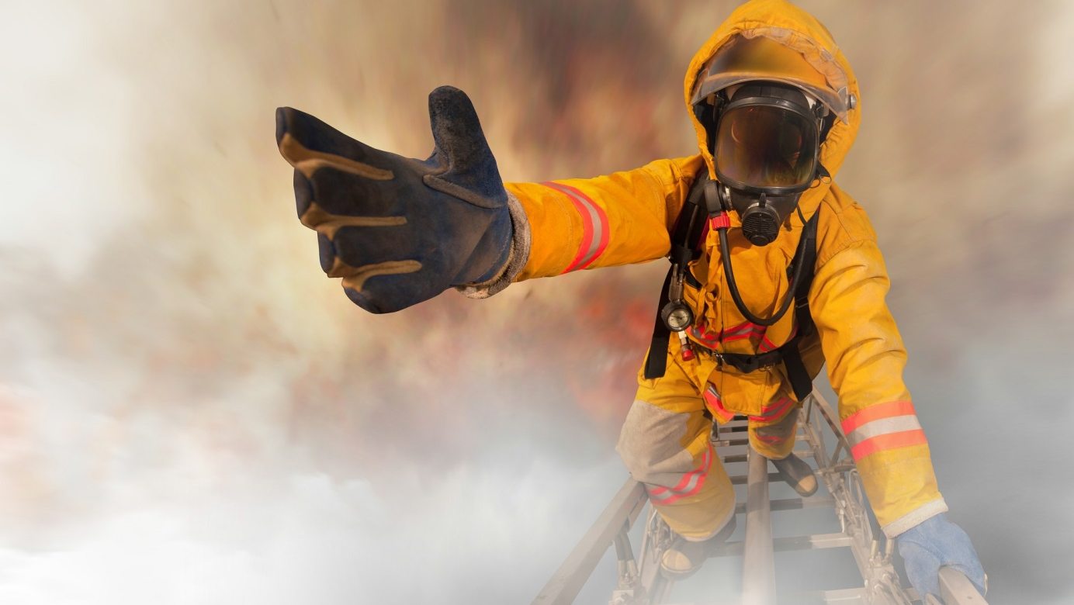
The most stressful professions
Recent studies carried out by the Safe at Work Coalition have shown that more than 80% Poles suffer from stress at work. Therefore, it is employers’ obligation to improve working conditions and hence eliminate, or at least minimise, its levels. However, there are professions where stress is an inherent element in virtually all activities undertaken.
Several factor influence the stress levels, but each individual feels them differently. Some cope easily while others could be petrified with fear.

Which jobs are the most stressful?
- Soldier, policeman and fire-fighter. A substantial amount of research demonstrates that jobs involving a threat to life are most stress-inducing. The key stress-inducing factor is the risk of losing life or health. During the recruitment, special psychological tests are conducted in order to determine how the candidate will perform at such a job.
- Doctor, nurse, midwife, pilot and flight controller. Another factor affecting stress levels is responsibility for others. This refers jobs entailing responsibility for the lives or health of other people.
- Journalist, actor, musician and dancer. Some people suffer from considerable stress when performing before large audiences.
- Jobs involving tight deadlines. Time, or more precisely – time constraints, i.e. having to keep deadlines, is another stress-inducing factor.

